Sampling is the process of selecting a subset of data from a population.
Data professionals use sampling because:
- It’s often impossible or impractical to collect data on the whole population due to size, complexity, or lack of accessibility
- It’s easier, faster, and more efficient to collect data from a sample
- Using a sample saves money and resources
- Storing, organizing, and analyzing smaller datasets is usually easier, faster, and more reliable than dealing with extremely large datasets
The sampling process
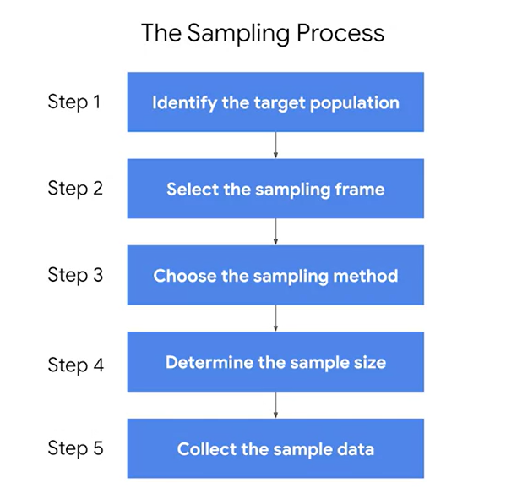
The target population is the complete set of elements that you’re interested in knowing more about
Generally your sampling frame is the accessible part of your target population, but sometimes it will include elements apart from this set.
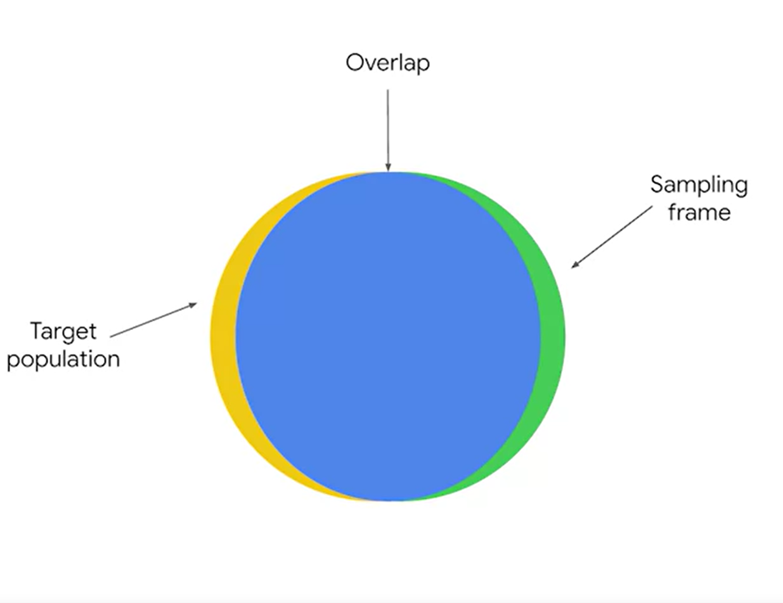
There are two main types of sampling methods: probability sampling and
non-probability sampling.
Probability sampling uses random selection to generate a sample.
Non-probability sampling is often based on convenience or the personal preferences of the researcher rather than random selection.
the larger the sample size, the more accurate your predictions. However, using larger samples typically requires more resources.

Probability sampling methods
There are four different probability sampling methods:
- Simple random sampling: every member of a population is selected randomly and has an equal chance of being chosen. You can randomly select members using a random number generator, or by another method of random selection.
- Stratified random sampling: you divide a population into groups, and randomly select some members from each group to be in the sample.
These groups are called strata. Strata can be organized by age, gender, income, or whatever category you’re interested in studying.
This method helps provide equal representation for underrepresented groups, and allows you to draw more precise conclusions about each of the strata.
- Cluster random sampling: you divide a population into clusters, randomly select certain clusters, and include all members from the chosen clusters in the sample.
Cluster sampling is similar to stratified random sampling, but in stratified sampling, you randomly choose some members from each group to be in the sample. In cluster sampling, you choose all members from a group to be in the sample.
- Systematic random sampling: you put every member of a population into an ordered sequence. Then, you choose a random starting point in the sequence and select members for your sample at regular intervals.
One disadvantage of systematic sampling is that you need to know the size of the population that you want to study before you begin. If you don’t have this information, it’s difficult to choose consistent intervals. Plus, if there’s a hidden pattern in the sequence, you might not get a representative sample.

A randomly chosen sample means that all members of the population have an equal chance of being included. In contrast, non-probability sampling methods do not use random selection, so they do not typically generate representative samples. In fact, non-probability methods often result in biased samples.
Non-probability sampling methods
- Convenience sampling: you choose members of a population that are easy to contact or reach. Often quick and inexpensive, but it’s not a reliable way to get a representative sample.
- Voluntary response sampling: consists of members of a population who volunteer to participate in a study. Instead of the researcher selecting participants, participants volunteer on their own.
Voluntary response samples tend to suffer from nonresponse bias, which occurs when certain groups of people are less likely to provide responses. People who voluntarily respond will likely have stronger opinions, either positive or negative, than the rest of the population.
- Snowball sampling: researchers recruit initial participants to be in a study and then ask them to recruit other people to participate in the study. Like a snowball, the sample size gets bigger and bigger as more participants join in. Researchers often use snowball sampling when the population they want to study is difficult to access.
This type of recruiting can also lead to sampling bias. Because initial participants recruit additional participants on their own, it’s likely that most of them will share similar characteristics, and these characteristics might be unrepresentative of the total population under study.
- Purposive sampling: Researchers select participants based on the purpose of their study. Because participants are selected for the sample according to the needs of the study, applicants who do not fit the profile are rejected.
Purposive sampling is often used when a researcher wants to gain detailed knowledge about a specific part of a population, or where the population is very small and its members all have similar characteristics. Purposive sampling is not effective for making inferences about a large and diverse population.

The standard deviation of a sample statistics is called STANDARD ERROR
The Central Limit Theory
It states that the sampling distribution of the mean approaches a normal distribution as the sample size increases. In other words, as the sample size increases, the sampling distribution assumes the shape of a bell curve. If a large enough sample of the population is used, the sample mean will be roughly equal to the population mean.
The central limit theorem holds true for any population. You don’t need to know the shape of your population distribution in advance to apply the theorem—the distribution could be bell-shaped, skewed, or have another shape. If you collect enough samples of sufficient size, the shape of the distribution of their means will follow a normal distribution.
In order to apply the central limit theorem, the following conditions must be met:
- Randomization: Your sample data must be the result of random selection.
- Independence: means that the value of one observation does not affect the value of another observation. Typically, if you know that the individuals or items in your dataset were selected randomly, you can also assume independence.
  - 10%: To help ensure that the condition of independence is met, your sample size should be no larger than 10% of the total population when the sample is drawn without replacement (which is usually the case).
    - Note: In general, you can sample with or without replacement. When a population element can be selected only one time, you are sampling without replacement. When a population element can be selected more than one time, you are sampling with replacement. You’ll learn more about this topic later on in the course.
- Sample size: The sample size needs to be sufficiently large.

The sampling distribution of the proportion
A sampling distribution is a probability distribution of a sample statistic.
You can use a sampling distribution to represent statistics such as the mean, median, standard deviation, range, and more.
The standard deviation of a sample statistic is called the standard error. The standard error provides a numerical measure of sampling variability. The standard error of the mean measures variability among all your sample means. A larger standard error indicates that the sample means are more spread out, or that there’s more variability. A smaller standard error indicates that the sample means are closer together, or that there’s less variability.
In practice, using a single sample of observations, you can apply the following formula to calculate the estimated standard error of the sample mean:
s / √n.
s refers to the sample standard deviation, and n refers to the sample size.

The sampling distribution of the mean refers to the probability distribution of the sample means, obtained by taking repeated samples of a fixed size (in this case, 10 trees) from a population. Here’s why:
When a data professional takes repeated samples (each of size 10 trees) and calculates the mean height for each sample, they get multiple sample means.
The sampling distribution is the distribution of these sample means, showing the probabilities of different mean values.
- Key Characteristics:
  - The sampling distribution of the mean is typically normal (bell-shaped), especially if the sample size is large enough (according to the Central Limit Theorem).
  - The mean of the sampling distribution (the expected value) is equal to the population mean.
  - The spread (standard deviation) of this distribution is called the standard error, which is the population standard deviation divided by the square root of the sample size (σn\frac{\sigma}{\sqrt{n}}n​σ​).

1. Sampling Distribution:
A sampling distribution is a probability distribution of a sample statistic. It tells us what we would expect if we were to take many samples from a population and compute a statistic (like the mean, proportion, or standard deviation) for each sample.
Example:
- Imagine you have a large population of 1,000 trees, and you want to know the average height of these trees.
- Instead of measuring the height of every tree (which could be difficult), you take a random sample of 10 trees and find the average height of those 10.
- If you repeat this process many times (taking different samples of 10 trees each time), you will get different sample means.
- The distribution of all these sample means is called the sampling distribution of the mean.
2. Standard Error:
The standard error is a measure of the variability or spread of the sample statistic (e.g., the sample mean) across different samples.
- Standard Error of the Mean measures how much the sample means vary from one sample to another.
- It is calculated using the formula:
Standard Error (SE)=sn\text{Standard Error (SE)} = \frac{s}{\sqrt{n}}Standard Error (SE)=n​s​
Where:
- sss is the sample standard deviation (a measure of how spread out the data is in your sample).
- nnn is the sample size (the number of observations in each sample).
3. Interpreting Standard Error:
- A larger standard error means that the sample means are more spread out, indicating more variability between samples.
- A smaller standard error means that the sample means are closer together, indicating less variability between samples.
Example:
- Suppose you are studying the heights of students in a school. You take a sample of 30 students and calculate the sample mean height.
- The sample standard deviation (sss) is 5 inches, and the sample size (nnn) is 30.
- The standard error would be:
SE=530≈0.91 inches\text{SE} = \frac{5}{\sqrt{30}} \approx 0.91 \text{ inches}SE=30​5​≈0.91 inches
This tells you that the sample means from different samples of 30 students tend to vary by about 0.91 inches.
4. Why is Standard Error Important?
- The standard error gives us an idea of how precise our sample statistic (e.g., mean) is as an estimate of the population parameter.
- A smaller standard error suggests that our sample mean is a good estimate of the population mean.
- A larger standard error suggests more uncertainty and less precision in our estimate.
5. Real-Life Application:
In research, we often work with only one sample. However, by calculating the standard error, we get an idea of how much our sample mean might differ from the true population mean. This helps us make inferences and assess the reliability of our estimates.
In summary:
- A sampling distribution shows the probability distribution of a sample statistic (like the mean).
- The standard error measures the variability of this statistic across samples.
- The formula sn\frac{s}{\sqrt{n}}n​s​ helps us estimate the standard error based on the data from a single sample.

A standard error is the standard deviation of a sample statistic. A sampling distribution is a probability distribution of a sample statistic.

